Financial Document Extraction Platform

Purpose of this document

This document explains the design and implementation of the AI-Powered Financial Document Extraction Platform. It describes the business problem, proposed solution, system architecture, technical approach, data processing flow, and storage model used to automatically extract, validate, and analyze financial data from multi-format documents.
This document provides an overview of the platform including the business challenges, solution approach, product capabilities, objectives, and high-level architecture. It also explains the technical design such as multi-format parsing, OCR processing, LLM-based extraction, prompt strategy, data normalization, validation, end-to-end workflow, data modeling, storage architecture, and the suggested technology stack.

Business Level Overview

Problem Statement

Financial institutions and investment companies deal with a large number of financial documents every day - like monthly reports, borrower details, fund documents, security filings, and compliance papers. These documents come in many different formats.

Challenge | Description
Different formats | Financial data comes as PDFs, Excel files, CSV, XML, and even scanned images. Each type needs a different way to read the data.
Inconsistent Structure | Even in the same format (like PDF), tables, column names, metrics, and currency styles can be very different depending on the company or report period.
Manual work takes time | Analysts spend most of their time finding tables, copying data, and cleaning it instead of actually analyzing it.
Mistakes happen easily | Manual typing can cause errors like wrong numbers, missing

 | rows, or incorrect dates, which affects reports and decisions.
Data is scattered | Extracted data is stored in many spreadsheets, so comparing companies, finding trends, or spotting issues becomes difficult.
No tracking | It’s hard to know where a specific data value came from (which  file or page), which can create compliance and audit problems.

Our Solution
AI-powered platform that reads financial documents, extracts important data points, and validates the accuracy of the data, standardize the data, and enable visualizations and reporting - handling everything from uploading the files to analyzing the data in one system.
Product Capabilities
Capability | Description
Upload multiple file types | The system can take PDFs, Excel, CSV, XML, and images. It automatically detects the file type and processes it correctly.
AI-powered data extraction | AI models read the documents and pull important financial numbers from tables and text, even if the data is not well structured.
Read scanned images | If the document is an image or scanned file, OCR tools convert the image into text before AI extracts the data.
Standardization of data | The system converts different names and formats into one common format (for example, changing different sales names into a standard name, fixing currency, and date formats).
Check data accuracy | The platform verifies numbers using basic calculations, highlights unusual values, and gives a confidence score
Data storage | All extracted data is saved in a database along with details like the source file, page number, time of extraction, and accuracy level.

Objectives
- Reduce manual data extraction effort by decreasing the time analysts spend processing each report.
- Improve extraction accuracy by minimizing errors in the extracted financial data.
- Support multiple formats by enabling the system to handle PDFs, Excel, CSV, XML, and images.

- Ensure scalability by allowing the system to process many documents at the same time.
- Enable source traceability by tracking each data point back to its original document and page.
- Support self-improving extraction by continuously improving AI accuracy using feedback and corrections.

High-Level Architecture
The platform is composed of six core layers:

Layer | Components | What it does
Document Upload | File upload API, format detector, file validator | Users upload documents through UI. The system checks the file, saves the original copy, and identifies the file type.
AI Extraction | LLM engine, OCR tools, prompt manager | The system converts documents (including images) into text and uses AI to extract important financial data from tables and content.
Verification Agent | Cross check extracted value against the original document text | It catches the missed field , inconsistence data
Re-generate | Auto-generates a corrected prompt and re-runs extraction | Self-corrects errors
Learning Engine | Aggregates discrepancy logs, detects recurring error patterns, auto-refines prompt templates | System improve
Data Processing | Schema mapper, normalizer, validator, conflict resolver | Extracted data is converted into a standard format, cleaned, validated with calculations, and given a confidence score.
Storage | PostgreSQL, Object Storage, Redis | Saves structured data, keeps raw files, and uses cache for faster performance.
Visualization | React dashboards, charts | Shows data in dashboards, trends, comparisons and allows export to

 | (Plotly/D3), export tools | PDF or Excel.
Orchestration & Monitoring | Redis Queue | Handles background processing, tracks system performance, sends alerts, and keeps logs for debugging and monitoring.

Architecture Diagram
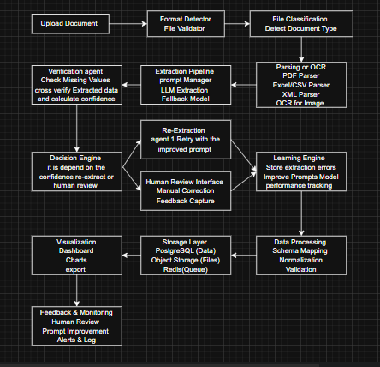

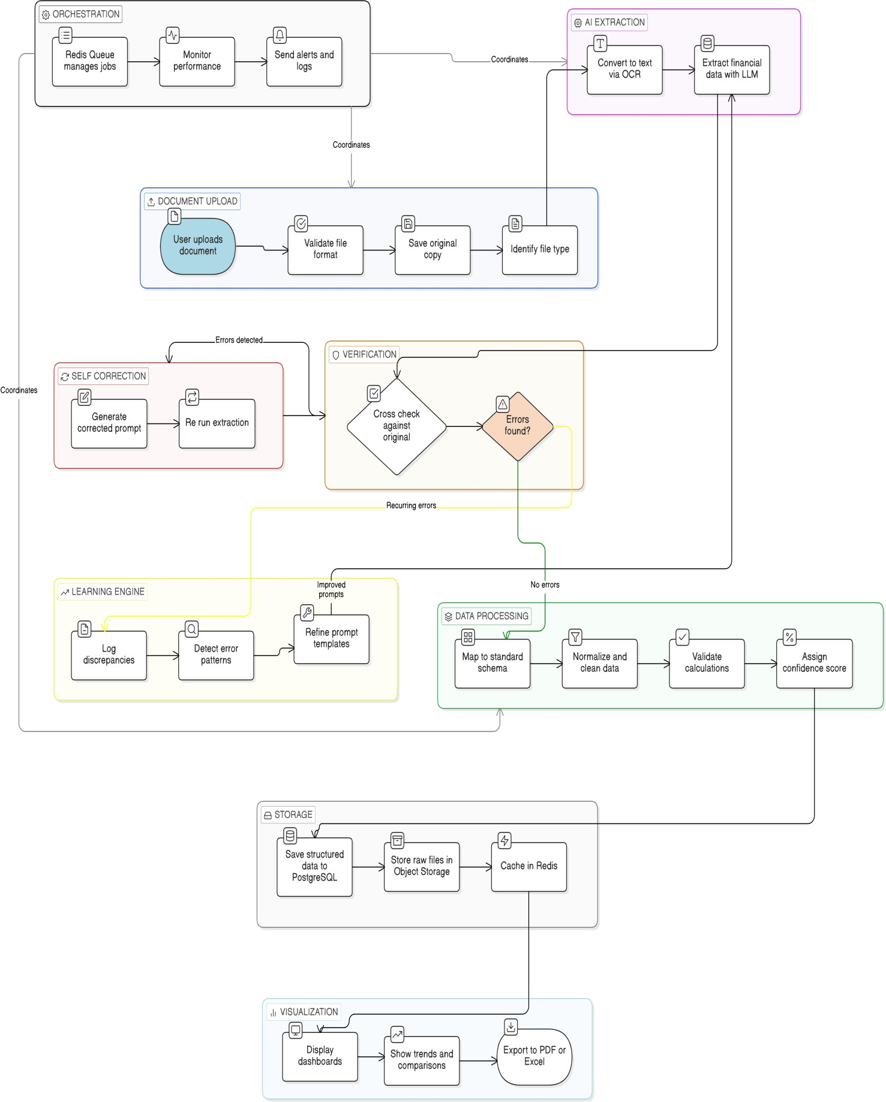

- Technical Details

Approach to Solve the Problem

Multi-Format Parser Strategy
Different file types are handled in different ways before sending the data to the AI. Each format is processed using the right method first, and then the cleaned text is passed to the AI for data extraction:

    - PDF: Use PyPDF2, pdfplumber, or Camelot to detect tables and extract text while preserving the layout, producing structured text with table boundaries.
    - Excel: Use openpyxl and pandas to detect sheets, identify header rows, and handle merged cells, resulting in clean table data as a DataFrame.
    - CSV: Use pandas to detect encoding, identify delimiters, and clean headers, producing structured table data as a DataFrame.
    - XML: Use lxml or ElementTree to detect schema (such as XBRL), resolve namespaces, and parse elements, resulting in structured XML data.
    - Images: Use Tesseract or Cloud Vision to preprocess images by straightening, removing noise, improving contrast, and detecting table areas, producing extracted text with positional details.

OCR Pipeline for Images
- Image cleaning:
Improve image quality using OpenCV (deskew, denoise, contrast, binarization).
- Table Detection:
Identify table areas using layout models like Detectron2 or custom detection.
- OCR text reading:
Extract text with Tesseract or Cloud Vision / Tesseract for better accuracy.
- Table reconstruction:
Rebuild rows and columns using text positions with Python (pandas + bounding boxes).
- AI extraction:

Send the reconstructed table text to LLMs (Gemini/GPT/Llama) to extract financial data.

LLM-Based Schema Extraction
The system uses AI in multiple steps to correctly understand documents and extract structured financial data.
  - Classification: The AI analyses the document to identify its type such as financial statement, report, or filing, and locates tables and key financial metrics.
  - Extraction: Using designed prompts, the AI extracts numbers and fields from the identified tables and returns them in a structured JSON format with standardized metric names.
  - Validation: The system verifies extracted values by checking calculations, identifying unusual data, and assigning a confidence score to each data point.
  - Enrichment: The system adds additional context such as company name, reporting period, currency, and page references, linking each value back to its source document.

Prompt Engineering Strategy
- Keep a collection of tested prompts for each document type and manage them with versions so they can be improved over time.
- Add sample inputs and outputs (few-shot examples) to help the AI understand complex table layouts.
- Include instructions on what the AI should not do (for example, don’t calculate values - only extract what exists in the document).
- Force the AI to return data in a strict JSON format and validate it using JSON schema to ensure consistency and accuracy.

Data Normalization & Validation
- Standard metric names:
Different names that mean the same thing are converted into one standard name (for example, “Gross Sales” becomes “Total Gross Sales”) using a mapping table.

Standard date format:
Dates written in different styles (like Feb-25, February 2025, 2/25) are converted into one format such as YYYY-MM

Currency Handling:
The system detects currency units and adjusts values (for example, “$ in Thousands” means numbers
are multiplied by 1000).

Data type checking:
Ensures numbers are valid, dates are correct, and all required fields are present

Calculation checking:
Verifies basic formulas (for example, Gross Profit = Net Sales – COGS) to confirm the extracted data is accurate.

Handling Unknown Formats
- Format Detection: The system checks the file’s extension and internal file signature (magic bytes)
to identify the format.
- Fallback Process: If the format is unknown, the system treats it like an image, runs OCR to read text, and uses a general financial AI prompt to extract data.
- Human Review: Files with unrecognized formats are sent to a manual review

Detailed End-to-End Flow Step-by-Step Workflow

Step | Component | Action | Error Handling
1. File Upload | Ingestion Service | Users upload files through UI, API, or folder. The system checks file size, format, and integrity. | Invalid files are rejected with a clear message; temporary issues are retried.
2. File Classification | Classifier | The system detects the file format and identifies the document type (financial report, statement, etc.). | Unknown formats go to a generic extraction flow and are flagged for review.
3. Parsing / OCR | Format- specific parser | The system reads content from PDFs, Excel, CSV, XML, or runs OCR for images/scanned files. | If parsing fails, another tool is tried; OCR failures are sent for manual review.
4. Data points and Mapping Configuration | Mapping Engine | Apply configured column mappings for the document. For example, “Grand Total” is converted to “Total Amount”. | If a new column name appears that is not mapped , it is flag for review
5. LLM | AI Engine | Parsed content is sent to AI | If AI fails or times out, a fallback

Extraction |  | with prompts to extract data in strict JSON format. | model is used; wrong JSON triggers retry with a stricter prompt.
6 . Verification  (Agent 2) | Verification | Second AI agent compares extracted values with the original document text to detect missing values, or incorrect numbers. It assigns a confidence score | If discrepancies are detected, the system flags the fields and sends them to the Decision Engine.
Decision Engine | Workflow Controller | Based on verification score: Accept extraction, trigger re-extraction with improved prompt, or send to human review. | Low-confidence results automatically trigger retries or human validation.
Learning &  Logging | Feedback Engine | All discrepancies, corrections, and retries are logged. This data improves prompts and model behavior over time. | If logging fails, events are stored in a temporary queue and retried.
7. Schema Mapping | Normalizer | Extracted fields are converted into standard names and structure. | Unknown fields go to review; unmapped fields are saved as raw data with a flag.
8. Data Validation | Validator | The system checks data types, ranges, and formulas. | major issues are sent to human review.
9. Storage | Database | Insert validated records into PostgreSQL with full metadata. | Database failures retry automatically;
10.  Visualization | Dashboard | Data appears in real-time dashboards. Charts, tables, KPIs update automatically. | If dashboards fail, data is shown in simple table view.

Phase 4: Data Modeling & Storage
Core Data Model
The database structure is designed to store and track the entire process:

Entity | Key Fields | Purpose

DOCUMENT | id (PK), filename, format, storage_path, uploaded_at, uploaded_by, status, document_type, processing_stage | Stores uploaded file metadata, detected document type, and overall processing status.
EXTRACTION | id (PK), document_id (FK), agent_type, llm_model, prompt_version, extraction_attempt, extracted_at, raw_response, status | Records each extraction attempt. Supports multiple retries and identifies which agent performed the extraction.
VERIFICATION | id (PK), extraction_id (FK), verifier_model, confidence_score, discrepancy_count, verification_result, verified_at | Stores results from Verification Agent that compares extracted data with original content.
FINANCIAL_DATA | id (PK), extraction_id (FK), company_name , metric_name, value, currency, source_page, human_verified | Stores structured financial data with traceability to the source document.
CORRECTION | id (PK), financial_data_id (FK), original_value, corrected_value, corrected_by, corrected_at, reason | Stores human corrections for audit trail and training data.
DISCREPANCY_LOG | id (PK), extraction_id (FK), field_name, extracted_value, detected_issue, severity, logged_at | Logs issues detected by the verification agent for learning and debugging.
PROCESS_LOG | id (PK), document_id (FK), stage_name, status, error_message, processed_at | Tracks the pipeline stages and errors across processing steps.

Suggested Tech Stack Summary
Layer | Technology | Justification
Frontend | React | Modern, scalable, strong ecosystem
Backend API | Azure Functions (Python) | Async, auto-docs, Python ML ecosystem
LLM | Local LLM + Google Gemini | POC-validated accuracy; local for data sensitivity
OCR | Tesseract + Google Cloud Vision | Open-source base + cloud accuracy
Database | PostgreSQL 16 | Robust, JSON support, extensibility

Object Storage | Local Disc/ S3 (prod) | S3-compatible API
Task Queue | Redis | Python-native, battle-tested
Caching | Redis | Fast, versatile

